

PRODUCT OF THE MONTH ALERT
March 2014

Fluke Calibration is announcing a new PCT marketing action : The product of the month.
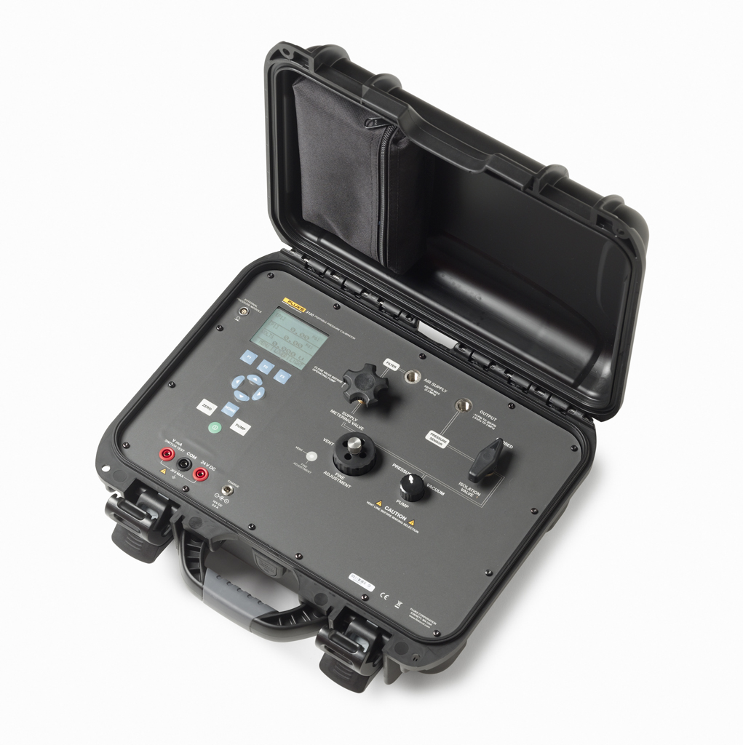
We want to promote each month a different PCT product. This promotion is an end-user promotion.

Product of the month March:
Fluke 3130 Pneumatic Pressure Calibrator
Message:
Buy an 3130 and get the accredited calibration for free.
(Discount to be shared 50/50 between FCAL and distributor)


Time frame:
March 1st till March 31st, 2014

How to order:
When ordering an 3130-G2M/C, please mention on your order:
28% discount on 3130-G2M/C (product of the month March).
(The 28% equals sharing the difference between 3130-G2M and 3130-G2M/C of the
net price)


How to promote:
- Contact your customers and inform them of this excellent offer
- Send the 3130 promotional html mail to your customer base
(Please contact gerda.meijer@fluke.nl for support needed to
make the mail in your own language and/or with your own logo and details)
- Place the promotional logo on your website
(in case different size logo is needed or different language, please contact gerda.meijer@fluke.nl)

We are willing to support you in closing the deal with your customer. Please contact us for further information.
Thank you for your assistance, good luck and successful selling.

Mark Finch
Product Marketing Manager PCAL

